

HydroLinX® Antifoam Emulsion

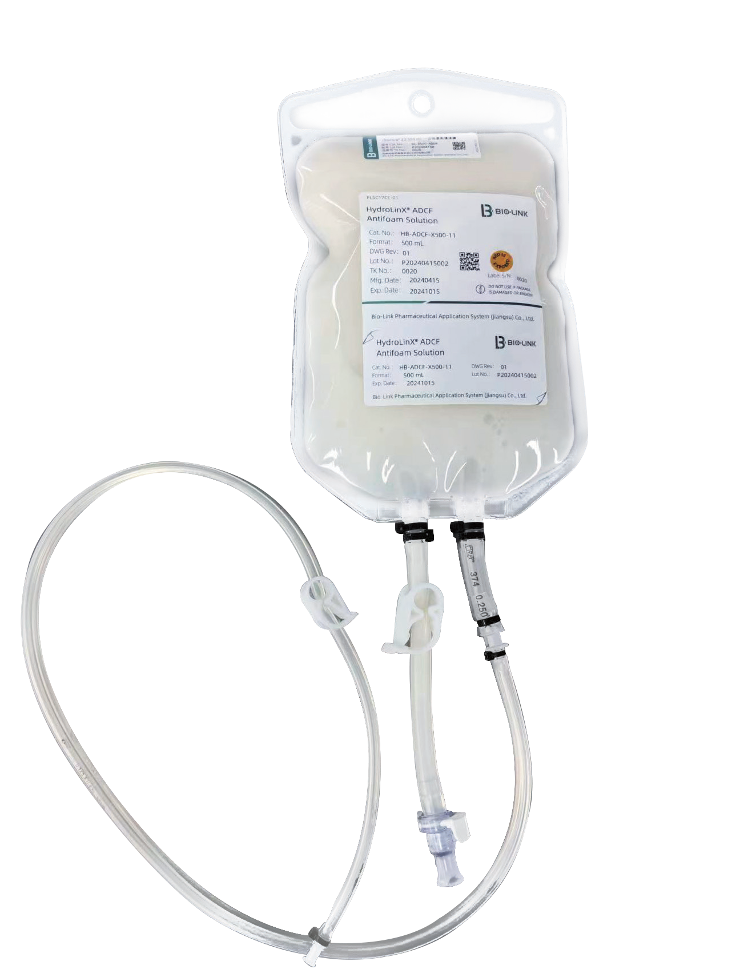
Product Features：
Irradiated sterilization Animal component-free Transport validation
Customizable connection methods DMF registration of raw materials

Applications：
HydroLinX® Antifoam Emulsion can be widely used
in the upstream cell culture and bioprocess antifoaming applications in biopharmaceutical manufacturing.

Lead Time:
45 days
Product Specifications and Ordering Information:
HA bottled, HB bagged

Cat. No. | Product Name | Volume (L) | Pack Size
HydroLinX® ADCF Antifoam Emulsion | HA-ADCF-X500-11 | 0.5 | 20
HydroLinX® ADCF Antifoam Emulsion | HB-ADCF-X500-11 | 0.5 | 12
HydroLinX® ADCF Antifoam Emulsion | HB-ADCF-T025-11 | 2.5 | 6
HydroLinX® ADCF Antifoam Emulsion | HB-ADCF-0005-11 | 5 | 2

